Chapter 2, Solution 64

The potentiometer (adjustable resistor) R_{x} in Fig. 2.126 is to be designed to adjust current I_{x} from 1 A to 10 A. Calculate the values of R and R_{x} to achieve this.
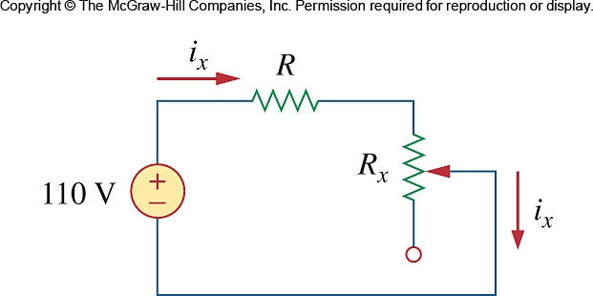

Figure 2.126
For Prob. 2.64.

Solution
When R_{x} = 0, R =
When R_{x} is maximum, i_{x} = 1A
i.e., R_{x} = 110 - R = 99 Ω
Thus, R = 11 Ω, R_{x} = 99 Ω

